Arts Education CEATE Awardee Workshop (Secondary)
Creative Thinking Teaching Strategy
Lesson Design

Unit : S.C.A.M.P.E.R. application
Teacher : Mr CHIU Shun-man
School : Immaculate Heart Of Mary College
Class : S4 Arts student
Date : 11th April, 2019
Time Allowed : 70 mins (1-double lesson 35+35 mins)

Knowledge : Students used iPads to design and draw on a photo by their creativities.
Objective : Students will acquire and apply knowledge and understanding of:
❖The elements in “S.C.A.M.P.E.R.”
❖The application of “S.C.A.M.P.E.R.”
❖The use of digital technologies to make their creative artworks.
Process:

Duration | Learning objectives | Learning activities and  Teaching materials | Note: (Preparation / Homework / Assessment / Extended learning)
5 mins | Analysis and Reflection on previous work  - Structure  - Use of colour  - Creativity | - Revision warmup activity  Each student use iPad and re-examine their own previous * “Street Art” works.  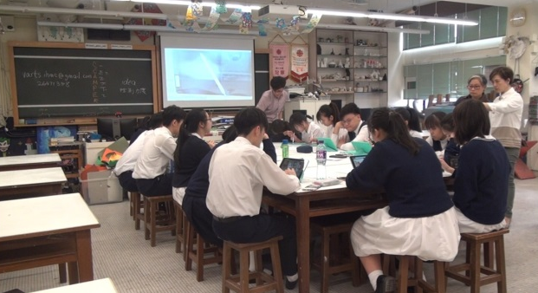  * Students randomly chose a corner within the school campus to develop their street art assignment. | iPads  (with  Adobe SKETCH apps installed)  Apple pencils
5 mins | Introduction of the elements in SCAMPER:  - definition  - examples  Understand the possibilities of the technique of SCAMPER | - Motivated warmup activity  Reference photo showing:  - Definition of S.C.A.M.P.E.R.  - Example application: “KitKat”  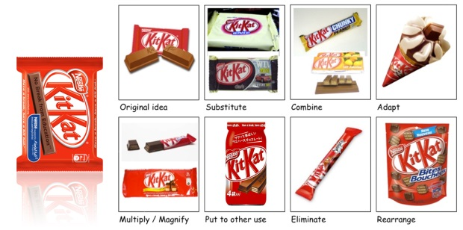 | Showing photos captured on Instagram
15 mins | Appreciation and identification of the artwork:  - Search the daily surfed creative photos on Instagram | - Voting activity  Students have to discuss among the classmates and say it loud the SCAMPER method used on the photos showing on the screen:  Examples:  - Project of Jr. @ Museum Louvre  (Rearrange)  - 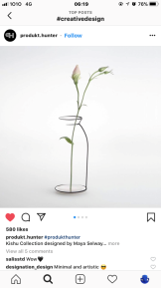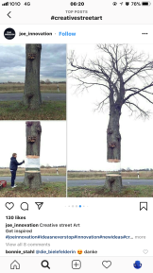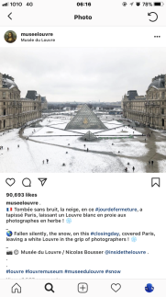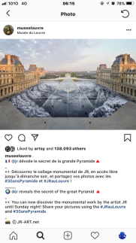(Elimination)  - 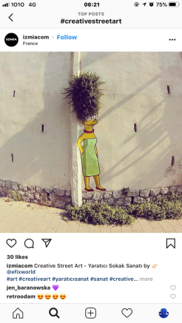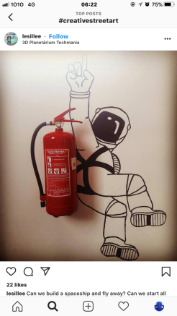(Combine)  Count the frequency of which element used most in the SCAMPER and write on the blackboard.  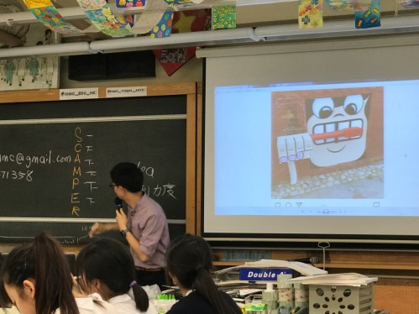 | Teacher’s computer  Projector  Showing photos captured on Instagram  Search: #creativestreetart  #creativedesign  A4 draft papers
20 mins | Experimental practice:  - Students have to download the pre-set photos  - Choose the most interesting photo  - Create their own digital artwork by applying the method of SCAMPER | - In-class activity  【Is it our tuck-shop!?】  Students can use their own iPads and Apple pencils to edit and rearrange the provided photos on the Google Drive:  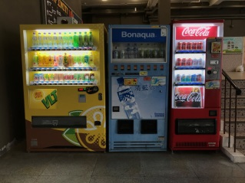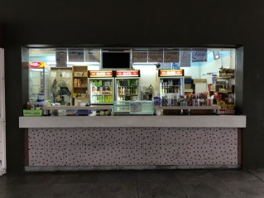The last 5 mins, students are reminded to add one more layer of the digital drawing in the iPad, for the use of peer commentary  Some students may find this task a bit difficult, as IT IS HARD to edit and manage digital devices.  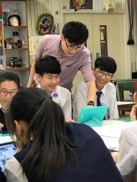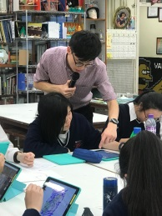 | iPads  (with  Autodesk SKETCHBOOK  apps installed)  Apple pencils  Google Drive
10 mins | Peer appreciation based on:  - Structure  - Use of colour  - Creativity | - Peer Appreciation  Students can walk around and appreciate other classmates’ works and use Apple pencil to write their own feelings towards the work  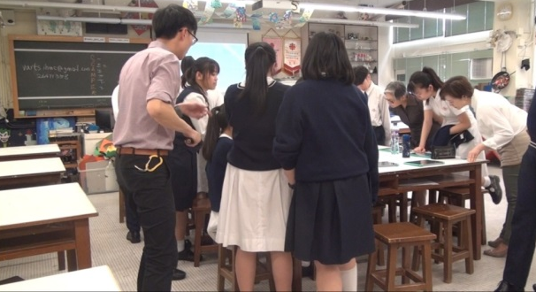  The last 5 mins, students are reminded to upload their whole work file onto the designated Google drive space after this session. | iPads  (with  Autodesk SKETCHBOOK  apps installed)  Apple pencils  Google Drive
10 mins | Summarized appreciation | - Summarization appreciation  After students uploaded their work on Google Drive, teacher can show on screen through projector simultaneously the good works by the students.  Teacher’s perspective of appreciation:  - Structure  - Use of colour  - Creativity  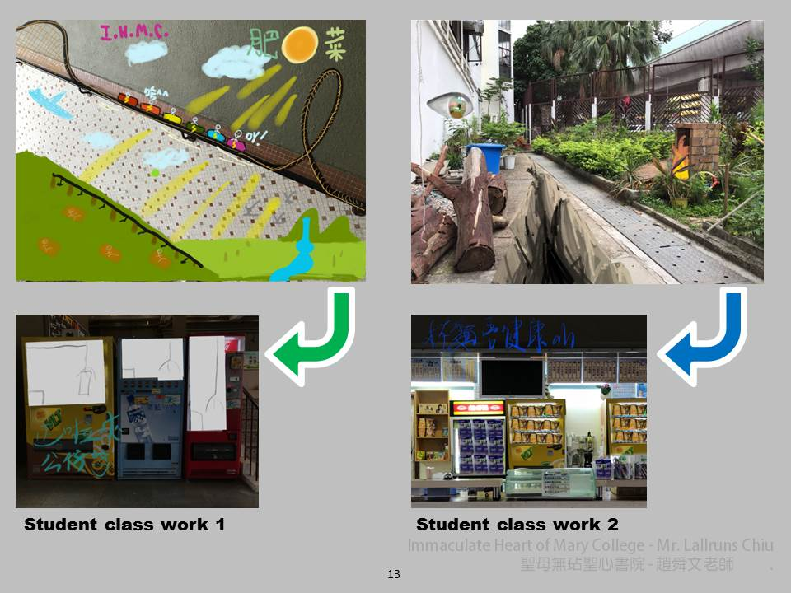 | Google Drive
5 mins | Conclusion and clean up | - Round up conclusion  Teacher reminds the students again the application of SCAMPER, and encourages them to use this method frequently. | Students should finish the work on their own

教學反思：

今年參加了卓師工作室的創意教學策略研究，當中有遇到困難與限制的，因為本人從工作室所學到的策略，是需要持續的去在課堂中試教，學生們才會更投入和配合指引，惟有時時間安排的局限，導致課堂效果未如理想。老師確實需要花時間去熟習這些創意教學策略，而且需要計劃好設計指定課堂給學生們去嘗試，學生也需要在多次接受這模式的上課方法後，才能有效地及更投入地善用這創意教學模式；創意教學策略是有根有據及有指引的教學模式，能令整體課堂整合及同一步伐地達成目標。最後在多次的重覆善用這次策略後，老師及學生雙方必能在創意能力上有所得益。
另外，我們所設計的教具都是以著實際的親身經歷，按學生們的較弱之處去製作出來的。 所以以著簡單的說明書去使用必能有所得益。
最後，本人覺得今年參加卓師工作室的得著是非常多的，因為除了在試教觀課的一次嘗試運用創意教學策略外，本人持續再嘗試在自己的課堂運用那些創意教學策略及方法，確實是有效令全班同學(高中選修VA)更投入課堂，例如在中四級試過運用double-diamond 以及 brainwriting方法幫助他們去發展SBA的主題和定出有效且有創意的4件作品大綱。若果分析教研前後的分別，本人發現是在教學上較之前更成熟，學生亦較投入課堂。

